Team GoGoSqueez
Title: Summons of Cthulhu.
Introduction:
Welcome to R'lyeh, the lost city that is the prison of Cthulhu. Traverse through the ever changing rooms and alleys that warp and change with each revisit. Clear the enemies in each room to travel to the next and collect items to help you in your quest to face Cthulhu.
Will you answer the summons of Cthulhu?

Instructions:
Use wasd to move. Space to dodge (can only be used once every 2 seconds). Use your mouse to aim and left click to shoot. The bullets will go towards the mouse/crosshair. Avoid getting hit or coming into contact with enemies. Defeat all the enemies and move to the door at the top of the room to go to the next room.When you lose all your hearts it's game over. Upon death all items and progress are reset and the game is random. Each time you play every 5 rooms will reward an item every 10 will be a boss. Face cthulhu in room 22. After beating a bos use the stairs to go to the next floor

Notes:
The player may encounter some bugs in their run that will impact gameplay. The doors at the bottom of the screen have no collision, the player can walk through them and get outside the map borders. The enemies if bunched too close together will cause them to shift their position when moving due to their collision. Players who avoid walking through the bottom door will avoid getting outside the map. However there is no way for the enemies (specifically zombies) to stop from bunching up as they follow the player around the room and due to their spawning position.

Enemies:
Cultist 3 health, shoots at player and takes half a heart
Bug: 2 health, does contact damage and takes half a heart
Zombie: 4 health, does contact damage and take a full heart
Mine: 3 health, explodes after 8 seconds and take half a heart
Sentry: 6 health, constantly shoots at player, take half life
Floor Boss 1: 10 health, shoots at player and take full heart
Floor Boss 2: 13 health, shoots at player
Cthulhu: 20 health, can shoot like the cultist, spam a circle of bullets like the mine and has contact damage like the zombie

Items:
Extra Heart: gives a new heart container
Double damage: doubles the damage to the player
Fire rate : increases the fire rate of the player
Shield: Allows for One free hit for room that wont damage the player
SpeedBoots: increases the speed of the player

Jar:https://drive.google.com/file/d/19K0eJvZNw-2To-V5lvn8a9-E2g-InN1I/view?usp=drive_link
GitHub: https://github.com/RiotKings/Ser225
Video (MP4 file): https://www.youtube.com/watch?v=NZegqXVIP1c

Screen Shots:

Title screen-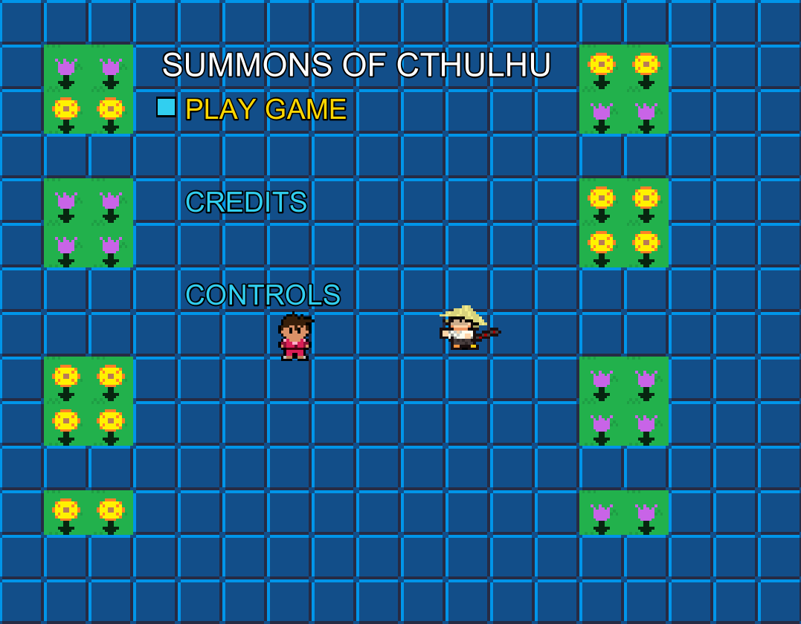
Items-
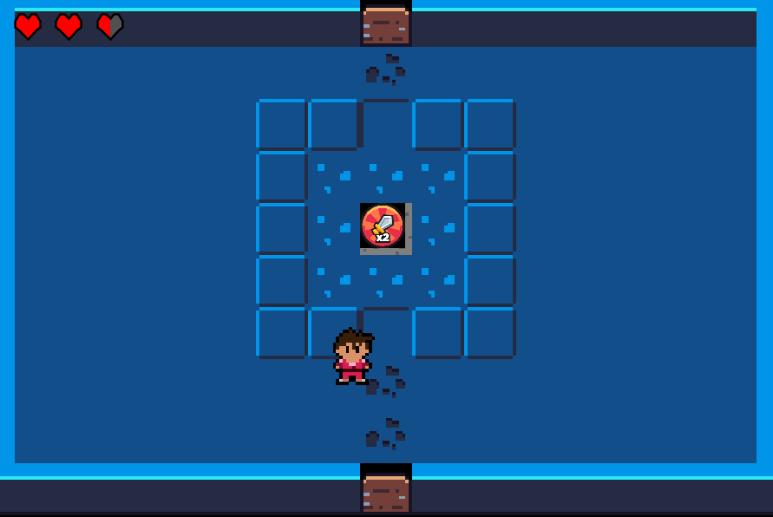
Floor 1-
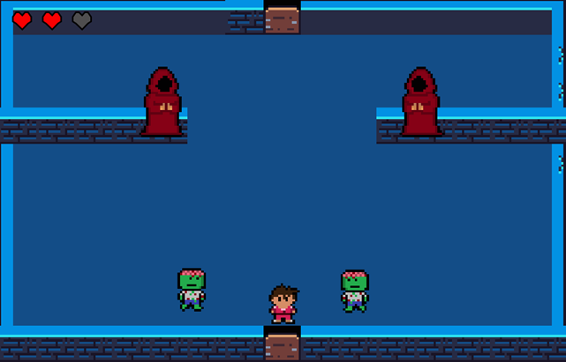
Floor 2-
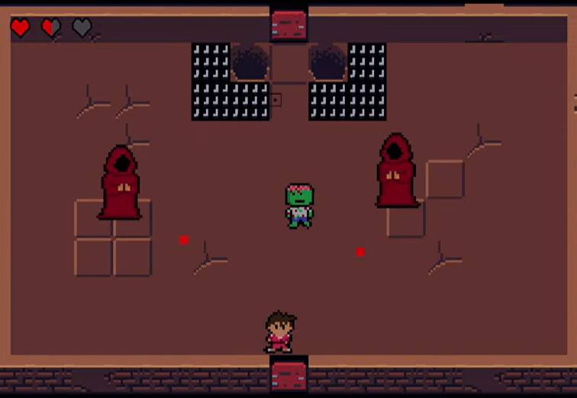
Final Boss-
